**WORK FROM HOME DETECTION**

Submitted in partial fulfillment of requirements for the award of the degree of

**B. TECH**

**COMPUTER SCIENCE AND ENGINEERING**

SUBMITTED BY

DHEERAJ SINGH (CSE/17/130)

Under the Guidance

Of



Department of Computer Science and Engineering

**B.M. Institute of Engineering and Technology Sector-10, Sonipat**

**(Affiliated to GGSIP University, Delhi)**

**Certificate**

It is to certify that the project has been carried out by the students of 8th **Dheeraj Singh (CSE/17/130)** under my guidance. The report covers all the aspects of the work done (including H/W & S/W, Coding, etc.).

The project report is complete in all respects and I have understood the entire software.

Manisha mam

**Certificate**

It is to certify that the project has been carried out by the student of 8th-semester Dheeraj Singh (CSE/17/130) under the guidance of Computer Science and Engineering Department. The report covers all the aspects of the work done (including H/W & S/W, Coding, etc.)

Prof. Pradeep Tyagi

H.O.D. COMPUTER SCIENCE AND ENGINEERING

**DEPARTMENT OF COMPUTER SCIENCE AND ENGINEERING**

**(AFFILIATED TO GURU GOBIND SINGH INDRAPRASTHA UNIVERSITY, DELHI) DELHI – 110089**

**CANDIDATE’S DECLARATION**

It is hereby certified that the work which is being presented in the B. Tech Minor Project Report entitled **"WORK FROM HOME DETECTION"** in partial fulfilment of the requirements for the award of the degree of **Bachelor of Technology** and submitted in the **Department of Computer Science and Engineering, B.M.I.E.T (Affiliated to Guru Gobind Singh Indraprastha University, Delhi)** is an authentic record of our own work carried out during a period from **JAN 2021 to JUNE ,2021** under the guidance of **GUIDE NAME**

The matter presented in the B.Tech Minor Project Report has not been submitted by me for the award of any other degree of this or any other Institute.

|  |  |
| --- | --- |
| Student name | Student Roll No |
| Dheeraj Singh | CSE/17/130 |

This is to certify that the above statement made by the candidate is correct to the best of my knowledge. They are permitted to appear in the External Major Project Examination.

**Manisha mam**

The B.Tech Minor Project Viva-Voce Examination of  **Dheeraj Singh (CSE/17/130)** has been held on **……………………………….**

**(Signature of External Examiner)**

**ACKNOWLEDGEMENT**

We express our deep gratitude to **Manisha mam**, Department of Computer Science and Engineering for her valuable guidance and suggestion throughout my project work.

We would like to extend my sincere thanks to HOD**,** for his time to time suggestions to complete my project work. I am also thankful to **Dr HARISH MITTAL** for providing me with the facilities to carry out my project work.

Dheeraj Singh (CSE/17/130)

**ABSTRACT**

The face is the representation of one’s identity. Hence, we have proposed an work from home detection application based on face recognition. Face recognition system is very useful in life applications especially in security control systems. The airport protection system uses face recognition to identify suspects and FBI (Federal Bureau of Investigation) uses face recognition for criminal investigations. In our proposed approach, firstly, video framing is performed by activating the camera through a user-friendly interface. The face ROI is detected and segmented from the video frame by using the Viola-Jones algorithm. In the pre-processing stage, scaling of the size of images is performed if necessary in order to prevent loss of information. The median filtering is applied to remove noise followed by conversion of colour images to grayscale images. After that, contrast-limited adaptive histogram equalization (CLAHE) is implemented on images to enhance the contrast of images. In face recognition stage, enhanced local binary pattern (LBP) and principal component analysis (PCA) is applied correspondingly in order to extract the features from facial images. In our proposed approach, the enhanced local binary pattern outperforms the original LBP by reducing the illumination effect and increasing the recognition rate. Next, the features extracted from the test images are compared with the features extracted from the stored images. The facial images are then classified and recognized based on the best result obtained from the combination of algorithm, enhanced LBP and PCA. Finally, the presesence of the recognized employee will be marked and saved in the log(text) file. The employee who is not registered will also be able to register on the spot and notification will be given if employee sign in more than once. The average accuracy of recognition is 100 % for good quality images, 94.12 % of low-quality images and 95.76 % for Yale face database when two images per person are trained.

**TABLE OF CONTENTS**

|  |  |
| --- | --- |
| 1. | Introduction |
| 2. | Technology used |
| 3. | Design / Implementation |
| 4. | Testing / Result and Analysis |
| 5. | Conclusions & future enchancements |
| 6. | References |

**INTRODUCTION**

The main objective of this project is to develop work from home detection application . In order to achieve better performance, the test images and training/stored images of this proposed approach are limited to frontal and upright facial images that consist of a single face only. The test images and training images have to be captured by using the same device to ensure no quality difference. In addition, the employee have to register in the database to be recognized. The registration can be done on the spot through the user-friendly interface.

**Background**

Face recognition is crucial in daily life in order to identify family, friends or someone we are familiar with. We might not perceive that several steps have actually taken in order to identify human faces. Human intelligence allows us to receive information and interpret the information in the recognition process. We receive information through the image projected into our eyes, by specifical retina in the form of light. Light is a form of electromagnetic waves which are radiated from a source onto an object and projected to human vision. Robinson-Riegler, G., & Robinson-Riegler, B. (2008) mentioned that after visual processing done by the human visual system, we actually classify shape, size, contour and the texture of the object in order to analyse the information. The analysed information will be compared to other representations of objects or face that exist in our memory to recognize. In fact, it is a hard challenge to build an automated system to have the same capability as a human to recognize faces. However, we need large memory to recognize different faces, for example, in the Universities, there are a lot of students with different race and gender, it is impossible to remember every face of the individual without making mistakes. In order to overcome human limitations, computers with almost limitless memory, high processing speed and power are used in face recognition systems.

The human face is a unique representation of individual identity. Thus, face recognition is defined as a biometric method in which identification of an individual is performed by comparing the real-time capture image with stored images in the database of that person (Margaret Rouse, 2012).

Nowadays, the face recognition system is prevalent due to its simplicity and awesome performance. For instance, airport protection systems and FBI use face recognition for criminal investigations by tracking suspects, missing children and drug activities (Robert Silk, 2017). Apart from that, Facebook which is a popular social networking website implement face recognition to allow the users to tag their friends in the photo for entertainment purposes (Sidney Fussell, 2018). Furthermore, Intel Company allows the users to use face recognition to get access to their online account (Reichert, C., 2017). Apple allows the users to unlock their mobile phone, iPhone X by using face recognition (deAgonia, M., 2017).

The work on face recognition began in 1960. Woody Bledsoe, Helen Chan Wolf and Charles Bisson had introduced a system which required the administrator to locate eyes, ears, nose and mouth from images. The distance and ratios between the located features and the common reference points are then calculated and compared. The studies are further enhanced by Goldstein, Harmon, and Lesk in 1970 by using other features such as hair colour and lip thickness to automate the recognition. In 1988, Kirby and Sirovich first suggested principle component analysis (PCA) to solve face recognition problem. Many studies on face recognition were then conducted continuously until today (Ashley DuVal, 2012).

**Problem Statement**

Due to covid pandemic the large scale of employees are working work from home. Which could be great loss for company if the employee is distracted or don’t work at all because no one knows what is he doing at home. This is the major problems in that situations for the employers as they are providing their salary but he would not get expected output.

Hence, there is a need to develop a real time operating work from detection system which means the identification process must be done within defined time constraints to prevent omission. The extracted features from facial images which represent the identity of the employee have to be consistent towards a change in background, illumination, pose and expression. High accuracy and fast computation time will be the evaluation points of the performance.

**Aim and Objectives**

The objective of this project is to develop face recognition base work from home detection app . Expected achievements in order to fulfill the objectives are: ∙

To register the application with username and password.

To capture the image.

* Capture the image
* Extract the features
* Store it with the name of user.

To login with the registered username and password.

To detect the face segment from the video frame.

∙ To extract the useful features from the face detected.

∙ To classify the features in order to recognize the face detected.

∙ To detect the presence of face in front of the camera.

To match the current video face to captured face.

To write in a log(text) fille.

To mail the log file with the summary of the content of log file

To logout

**LITERATURE REVIEW**

**Work from home detection system**

Disadvantages of RFID (Radio Frequency Identification) card system, fingerprint system and iris recognition system. RFID card system is implemented due to its simplicity. However, the user tends to help their friends to check in as long as they have their friend’s ID card. The fingerprint system is indeed effective but not efficient because it takes time for the verification process so the user has to line up and perform the verification one by one. However for face recognition, the human face is always exposed and contain less information compared to iris. Iris recognition system which contains more detail might invade the privacy of the user. Voice recognition is available, but it is less accurate compared to other methods. Hence, face recognition system is suggested to be implemented in the WFH-detection system.

Advantages & Disadvantages of Different Biometric System

|  |  |  |
| --- | --- | --- |
| **System type** | **Advantages** | **Disadvantages** |
| RFID card system | Simple | Fraudulent usage |
| Fingerprint system | Accurate | Time-consuming |
| Voice recognition system | Accurate | Less accurate compared to others |
| Iris recognition  system | Accurate | Privacy Invasion |

**Image Processing**

The facial recognition process can be split into two major stages: processing which occurs before detection involving face detection and alignment and later recognition is done using feature extraction and matching steps.

**FACE DETECTION**

The primary function of this step is to conclude whether the human faces emerge in a given image, and what is the location of these faces. The expected outputs of this step are patches which contain each face in the input image. In order to get a more robust and easily designable face recognition system. Face alignment is performed to rationalise the scales and orientation of these patches.

**FEATURE EXTRACTION**

Following the face detection step the extraction of human face patches from images is done. After this step, the conversion of face patch is done into vector with fixed coordinates or a set of landmark points.

**FACE RECOGNITION**

The last step after the representation of faces is to identify them. For automatic recognition we use the current user data and match with the current frame . Then when an input image is fed the face detection and feature extraction is performed and its feature to each face class is compared and write the log.

**ALGORITHM**

There are various algorithms used for facial recognition. Some of them are as follows:

1. Eigen faces

2. Fisher faces

3. Local binary patterns histograms

**EIGEN FACES**

This method is a statistical plan. The characteristic which influences the images is derived by this algorithm. The whole recognition method will depend on the training database that will be provided. The images from two different classes are not treated individually.

**FISHER FACES**

Fisher faces algorithm also follows a progressive approach just like the Eigen faces. This method is a alteration of Eigen faces so it uses the same principal Components Analysis. The major conversion is that the fisher faces considers the classes. As mentioned previously, the Eigen faces does not differentiate between the two pictures from two differed classes while training. The total average affects each picture. A Fisher face employs Linear Discriminant Analysis for distinguishing between pictures from a different class.

**LOCAL BINARY PATTERNS HISTOGRAMS**

This method needs the gray scale pictures for dealing with the training part. This algorithm in comparison to other algorithms is not a holistic approach.

1. **PARAMETERS**

LBPH uses the following parameters:

**Radius -** Generally 1 is set as a radius for the circular local binary pattern which denotes the radius around the central pixel.

**Neighbours -** The number of sample points surrounding the central pixel which is generally 8.The computational cost will increase with increase in number of sample points.

**Grid X -** The number of cells along the horizontal direction is represented as Grid X. With the increase in number of cells the grid becomes finer which results in increase of dimensional feature vector.

**Grid Y -** The number of cells along the vertical direction is represented as Grid Y. With the increase in number of cells the grid becomes finer which results in increase of dimensional feature vector.

1. **ALGORITHM TRAINING**

For the training purpose of the dataset of the facial images of the people to be recognized along with the unique ID is required so that the presented approach will utilize the provided information for perceiving an input image and providing the output. Same images require same ID.

1. **COMPUTATION OF THE ALGORITHM**

The intermediate image with improved facial characteristics which corresponds to the original image is created in the first step. Based on the parameters provided, sliding window theory is used in order to achieve so. Facial image is converted into gray scale. A 3x3 pixels window is taken which can also be expressed as a 3x3 matrix which contains the intensity of each pixel (0-255). After this we consider the central value of the matrix which we take as the threshold. This value defines the new values obtained from the 8 neighbours. A new binary value is set for each neighbour of the central value. For the values equal to or greater than the threshold value 1 will be the output otherwise 0 will be the output. Only binary values will be present in the matrix and the concatenation is performed at each position to get new values at each position. Then the conversion of this binary value into a decimal value is done which is made the central value of the matrix. It is a pixel of the actual image. As the process is completed, we get a new image which serves as the better characteristics of the original image.

1. **EXTRACTION OF HISTOGRAM**

The image obtained in the previous step uses the Grid X and Grid Y parameters and the image is split into multiple grids. Based on the image the histogram can be extracted as below: 1. The image is in gray scale and each histogram will consist of only 256 positions (0-255) which symbolises the existences of each pixel intensity. 2. After this each histogram is created and a new and bigger histogram is done. Let us suppose that there are 8x8 grids, then there will be 16.384 positions in total in the final histogram. Ultimately the histogram signifies the features of the actual image.

1. **THE FACE RECOGNITION**

The training of the algorithm is done. For finding the image which is same as the input image, the two histograms are compared and the image corresponding to the nearest histogram is returned. Different approaches are used for the calculation of distance between the two histograms. Here we use the Euclidean distance based on the formula:

𝐷 = √∑ 𝑛 𝑖=1 (ℎ𝑖𝑠𝑡1𝑖 − ℎ𝑖𝑠𝑡2𝑖 ) 2

Hence the result of this method is the ID of the image which has the nearest histogram. It should return the distance calculated in the form of ‘confidence’. Then the threshold and the ‘confidence’ can be used to automatically evaluate if the image is correctly recognized. If the confidence is less than the given threshold value, it implies that the image has been well recognized by the algorithm.

**ADVANTAGES OF USING LBPH ALGORITHM:**

1. It is one of the simplest algorithms for face recognition.

2. The local features of the images can be characterized by this algorithm.

3. Using this algorithm, considerable results can be obtained.

4. Open CV library is used to implement LBPH algorithm.

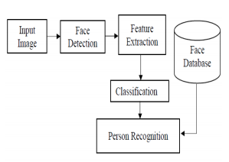

**DATABASE CREATION:**

The first step in the work from home detection System is the creation of a database/directories of faces that will be used. Different individuals are considered and a camera is used for the detection of faces and the recording of the frontal face. The number of frame to be taken for consideration can be modified for accuracy levels. These images are then stored in the database /directory along with the username.

**TRAINING OF FACES:**

The images are saved in gray scale after being recorded by a camera. The LBPH recognizer is employed to coach these faces because the coaching sets the resolution and therefore the recognized face resolutions are completely variant. A part of the image is taken as the centre and the neighbours are thresholded against it. If the intensity of the centre part is greater or equal than it neighbour then it is denoted as 1 and 0 if not. This will result in binary patterns generally known as LBP codes.

**FACE DETECTION:**

The data consist of faces is stored in .jpg format. The faces are detected using the Haar cascade frontal face module.

**FACE RECOGNITION:**

The stored faces are detected and current face are compared to it . The recording of faces is done in real time to guarantee the accuracy of the system. This system is precisely dependant on the camera’s condition.

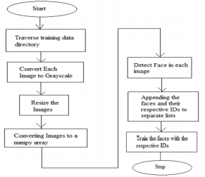

**HARDWARE SPECIFICATIONS:**

* Processor: Intel(R) Core(™) i3-8145U CPU @ 2.10Ghz 2.30 GHz
* Installed memory (RAM): 4.00 GB (3.86 GB usable)
* System type: 64-bit Operating System, x64-based processor

**SOFTWARE SPECIFICATIONS:**

* Python (version == 3.9.0)

Python is an interpreted, object-oriented, high-level programming language with dynamic semantics. Its high-level built in data structures, combined with dynamic typing and dynamic binding, make it very attractive for Rapid Application Development, as well as for use as a scripting or glue language to connect existing components together. Python's simple, easy to learn syntax emphasizes readability and therefore reduces the cost of program maintenance. Python supports modules and packages, which encourages program modularity and code reuse. The Python interpreter and the extensive standard library are available in source or binary form without charge for all major platforms, and can be freely distributed.

Often, programmers fall in love with Python because of the increased productivity it provides. Since there is no compilation step, the edit-test-debug cycle is incredibly fast. Debugging Python programs is easy: a bug or bad input will never cause a segmentation fault. Instead, when the interpreter discovers an error, it raises an exception. When the program doesn't catch the exception, the interpreter prints a stack trace. A source level debugger allows inspection of local and global variables, evaluation of arbitrary expressions, setting breakpoints, stepping through the code a line at a time, and so on. The debugger is written in Python itself, testifying to Python's introspective power. On the other hand, often the quickest way to debug a program is to add a few print statements to the source: the fast edit-test-debug cycle makes this simple approach very effective.

* Microsoft visual studio

Microsoft Visual Studio is an IDE made by Microsoft and used for different types of software development such as computer programs, websites, web apps, web services, and mobile apps. It contains completion tools, compilers, and other features to facilitate the software development process.

* Tkinter for GUI support

Tk/Tcl has long been an integral part of Python. It provides a robust and platform independent windowing toolkit, that is available to Python programmers using the [tkinter](https://docs.python.org/3/library/tkinter.html#module-tkinter) package, and its extension, the [tkinter.tix](https://docs.python.org/3/library/tkinter.tix.html#module-tkinter.tix) and the [tkinter.ttk](https://docs.python.org/3/library/tkinter.ttk.html#module-tkinter.ttk) modules.

The [tkinter](https://docs.python.org/3/library/tkinter.html#module-tkinter) package is a thin object-oriented layer on top of Tcl/Tk. To use [tkinter](https://docs.python.org/3/library/tkinter.html#module-tkinter), you don’t need to write Tcl code, but you will need to consult the Tk documentation, and occasionally the Tcl documentation. [tkinter](https://docs.python.org/3/library/tkinter.html#module-tkinter) is a set of wrappers that implement the Tk widgets as Python classes. In addition, the internal module _tkinter provides a threadsafe mechanism which allows Python and Tcl to interact.

[tkinter](https://docs.python.org/3/library/tkinter.html#module-tkinter)’s chief virtues are that it is fast, and that it usually comes bundled with Python. Although its standard documentation is weak, good material is available, which includes: references, tutorials, a book and others. [tkinter](https://docs.python.org/3/library/tkinter.html#module-tkinter) is also famous for having an outdated look and feel, which has been vastly improved in Tk 8.5. Nevertheless, there are many other GUI libraries that you could be interested in.

* Mysql 8.0

MySQL is [free and open-source software](https://en.wikipedia.org/wiki/Free_and_open-source_software) under the terms of the [GNU General Public License](https://en.wikipedia.org/wiki/GNU_General_Public_License), and is also available under a variety of [proprietary](https://en.wikipedia.org/wiki/Proprietary_software) licenses. MySQL was owned and sponsored by the [Swedish](https://en.wikipedia.org/wiki/Sweden) company [MySQL AB](https://en.wikipedia.org/wiki/MySQL_AB), which was bought by [Sun Microsystems](https://en.wikipedia.org/wiki/Sun_Microsystems) (now [Oracle Corporation](https://en.wikipedia.org/wiki/Oracle_Corporation)).[[8]](https://en.wikipedia.org/wiki/MySQL#cite_note-sunacquire-8) In 2010, when Oracle acquired Sun, Widenius [forked](https://en.wikipedia.org/wiki/Fork_(software_development)) the [open-source](https://en.wikipedia.org/wiki/Open-source) MySQL project to create [MariaDB](https://en.wikipedia.org/wiki/MariaDB).[[9]](https://en.wikipedia.org/wiki/MySQL#cite_note-9)

MySQL has stand-alone clients that allow users to interact directly with a MySQL database using SQL, but more often, MySQL is used with other programs to implement applications that need relational database capability. MySQL is a component of the [LAMP](https://en.wikipedia.org/wiki/LAMP_(software_bundle)) [web application](https://en.wikipedia.org/wiki/Web_application) [software stack](https://en.wikipedia.org/wiki/Software_stack) (and [others](https://en.wikipedia.org/wiki/List_of_AMP_packages)), which is an acronym for [*Linux*](https://en.wikipedia.org/wiki/Linux)*,*[*Apache*](https://en.wikipedia.org/wiki/Apache_HTTP_Server)*,*

**Implementation of face recognition**

The implementation of face recognition technology includes the following three stages:

* Image accquisition.
* Image processing.
* Face image classification and decision making.

**Image acquisition**

* Facial-scan technology can acquire faces from almost any static camera or video system that generates images of sufficient quality and resolution.
* High-quality enrolment is essential to eventual verification and identification enrolment images define the facial characteristics to be used in all future authentication events.

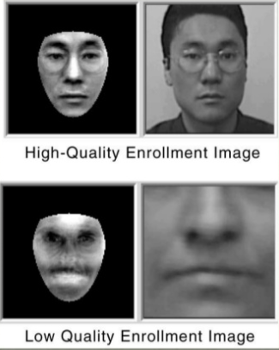

**Image Processing**

.

* First the presence of faces or face in a scene must be detected. Once the face is detected, it must be localized and normalization process may be required to bring the dimensions of the live facial sample in alignment with one on the template.

**Extraction of Facial features**

* All facial-scan systems attempt to match visible facial features in a fashion similar to the way people recognize one another.
* The features most often utilized in facial-scan systems are those least likely to change significantly over time: upper ridges of the eye sockets, area around the cheekbones, sides of the mouth, nose shape, and the position of major features relative to each other.

**How Facial Recognition System Works**

Every face has atleast 80 distinguishable parts called nodal points.

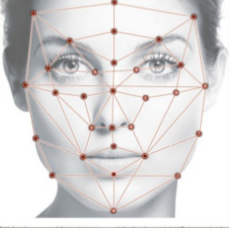

**How Facial Recognition System Works**

Here are few nodal points below:

* Distance between the eyes
* Width of the nose
* Depth of eye sockets
* Structure of the cheek bone
* Length of jaw line

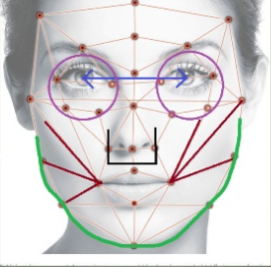

* A general face recognition software conducts a comparison of these parameters to the image in its database.
* Depending upon the matches found, it determines the result.
* This technique is known as feature based matching and it is the most basic method of facial recognition.

**Applications**

* Primary application being used in firms/classrooms to find the presence of employees/students.
* Decrease the false entry.
* Security/Counterterrorism: Access control, comparing surveillance images to know terrorist.
* Healthcare: Minimize fraud by verifying identity.

**Features**

1. Easy to use with interactive GUI support.
2. Password protection for new person registration.
3. Insert the data in mysql database for details of employee on registration.
4. Create a new log file (txt) everyday for writing the presence with proper date and time and can be updated if user login many a day times.
5. Display the time of joining with the username .

**SCREENSHOTS OF PROJECT**

**MAIN SCREEN -**

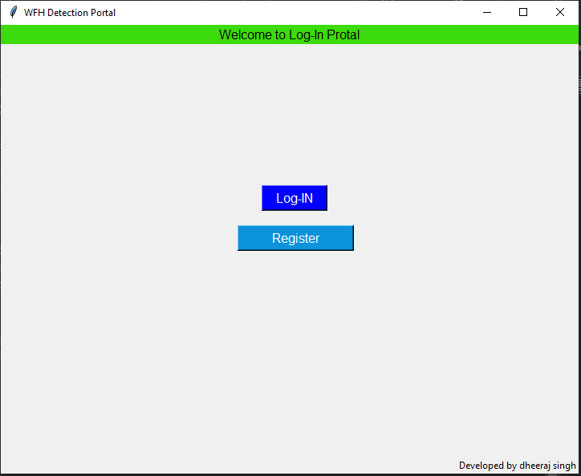

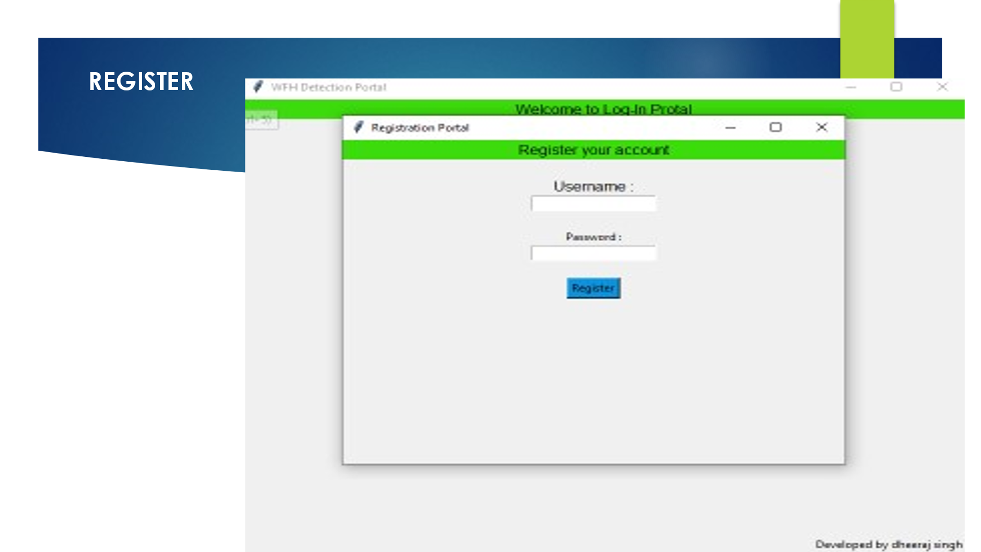

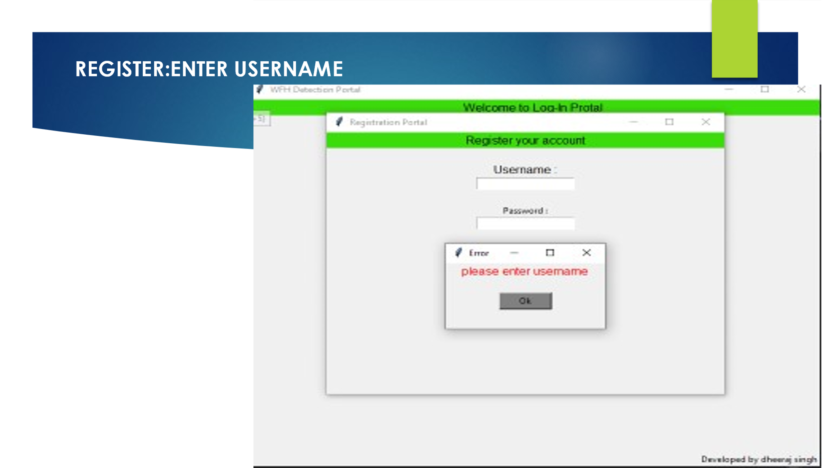

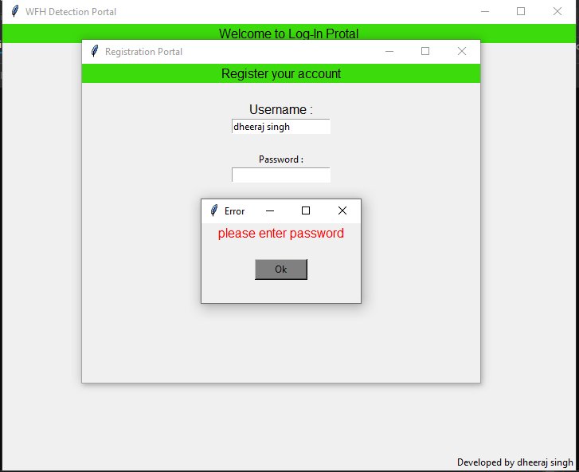

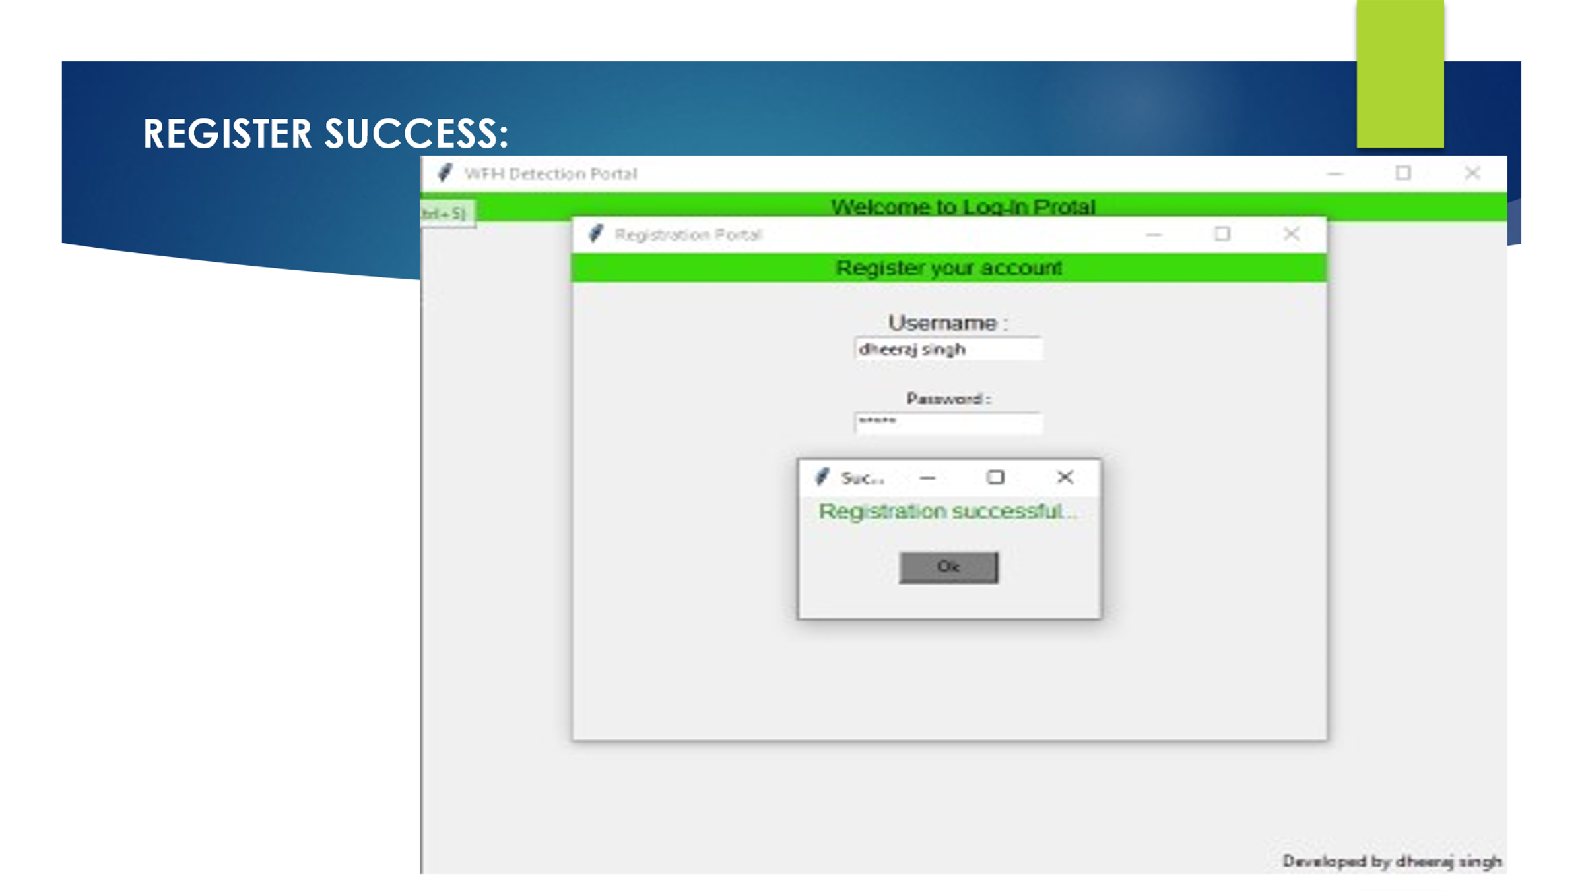

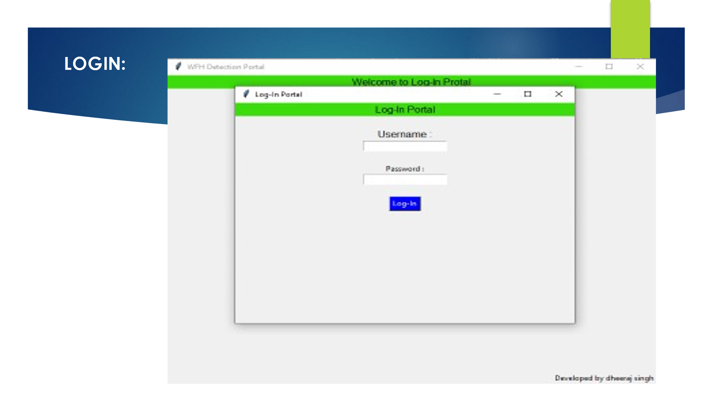

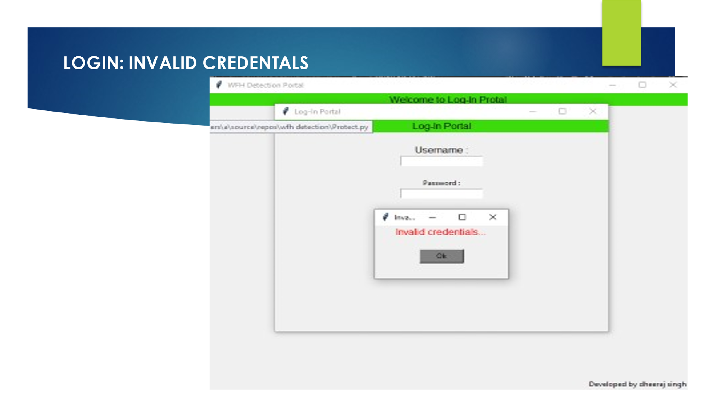

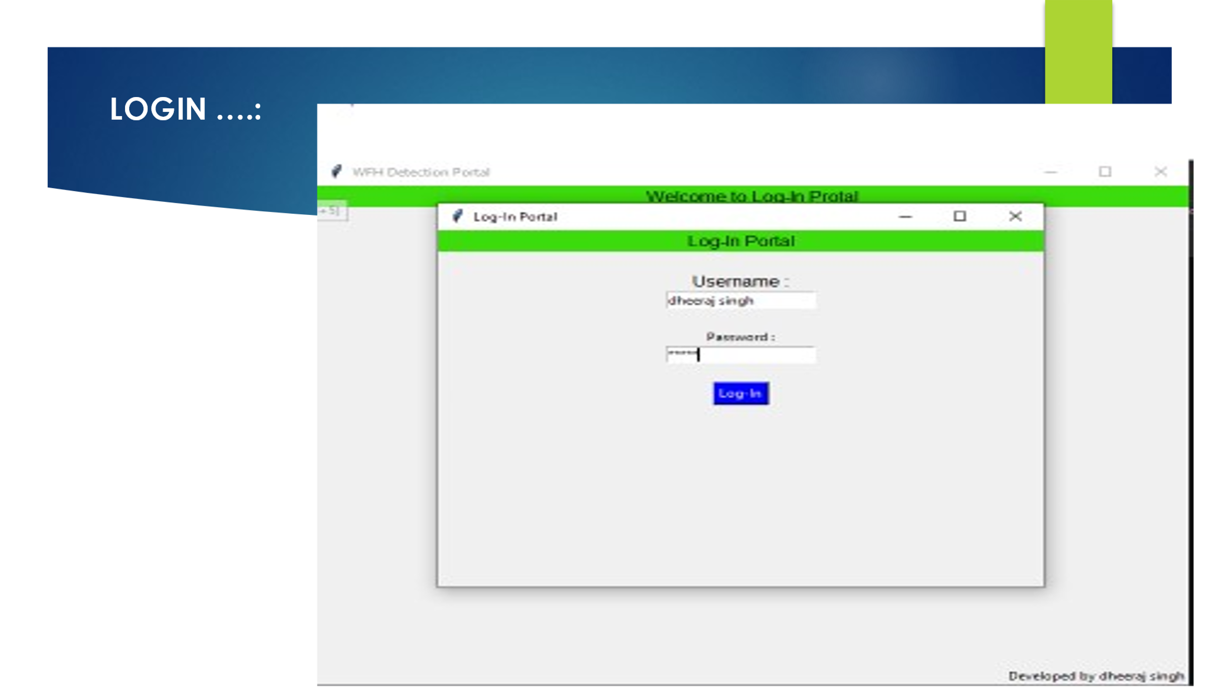

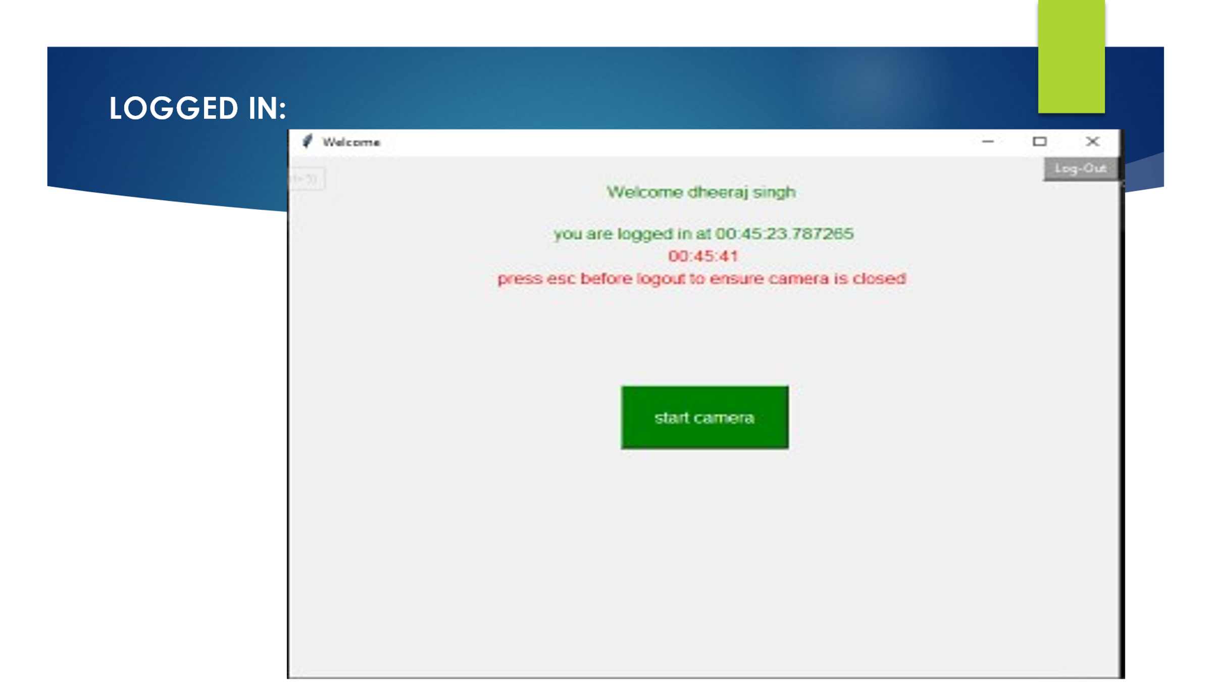



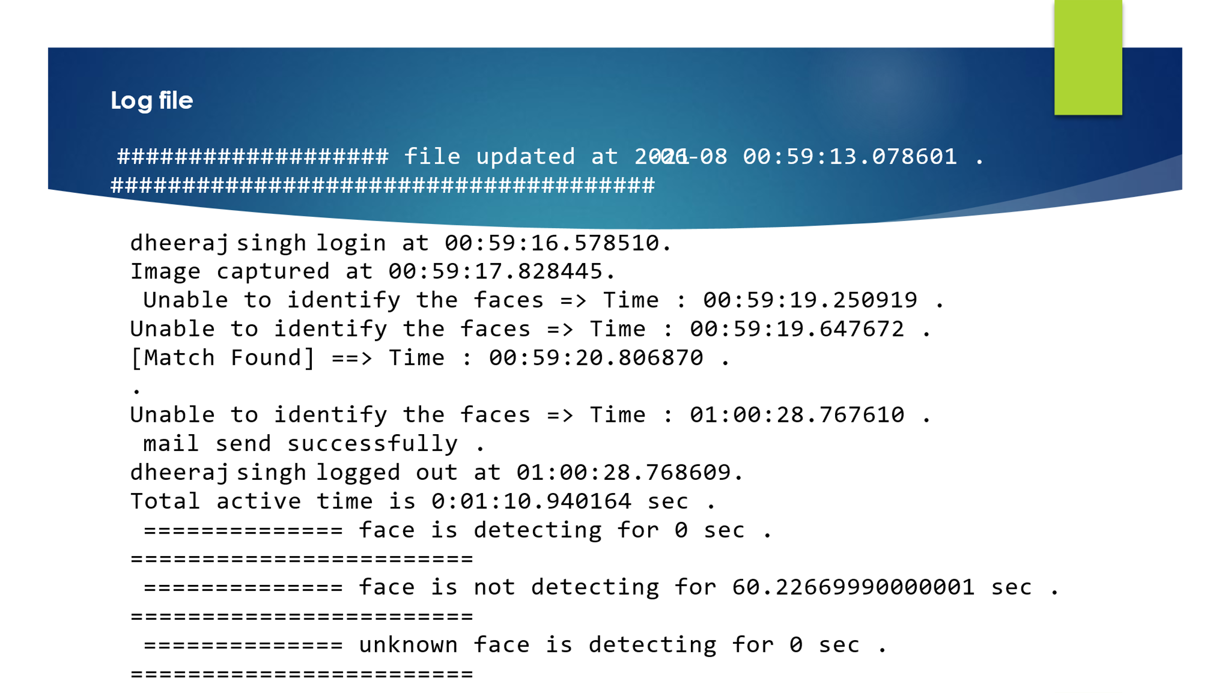

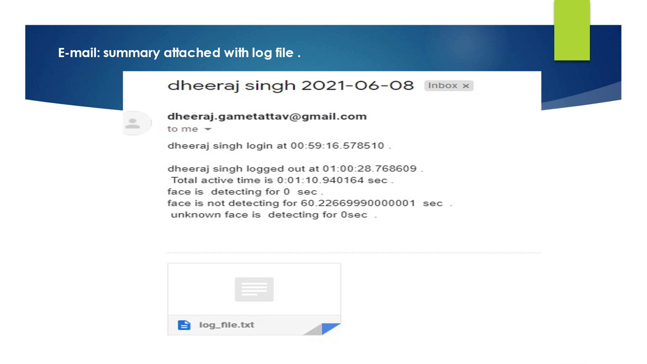

**Future Improvement Plan**

* Work on the security of the application
* To make the performance fast
* Storing all the data to server
* Using own mail server
* Develop front end for the employer
* Develop the administration section of the app.
* 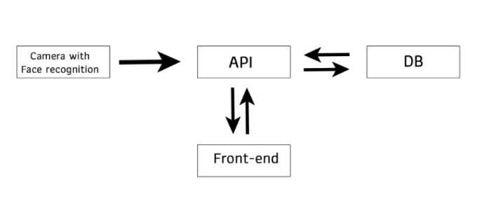

**References**

To understand the implementation of Face Recognition concept to use in our project we read some previously published research papers on internet and articles related to the same for reference. The links to the resources that helped us in making this project are given below:

* <https://www.researchgate.net/publication/326986115_Face_Detection_and_Recognition_Student_Attendance_System>
* <https://nevonprojects.com/face-recognition-attendance-system/>
* <https://www.youtube.com/watch?v=sz25xxF_AVE>
* <https://realpython.com/python-gui-tkinter/>
* https://docs.opencv.org/master/d9/df8/tutorial_root.html